4 X Idler Assembly

Vitamins
2 Ball bearing 624 4mm x 13mm x 5mm  2 LM8UU bearings  1 M3 cap screw x 35mm  1 M4 cap screw x 25mm  1 M3 cap screw x 18mm  1 Nyloc nut M3 | 1 Nyloc nut M4  2 Washer M3 x 7mm x 0.5mm  2 Washer M4 x 9mm x 0.8mm  1 Nut M3  1 M5 Brass nut

Printed
1 i3xends_v2_Idler.stl  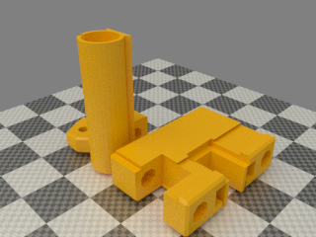 | 1 i3xends_v2_Idler_fork.stl  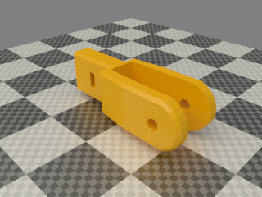 | 1 z_screw_isolator_left.stl  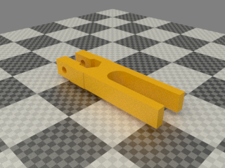

REPLACE 624 normal bearings with flanged type. Fork can rotate and belt will rub on the plastic. Also there is only so much room

Assembly

- Slide the 2 Idler parts together, they are a VERY tight fit. Don’t worry if they don’t slide completely together. When inserting the X rods they will home the last bit.
- Insert a M3 Nut in the idler fork. Slide it in the idler bits and insert a M3 35mm cap screw with a washers from the end of the idler, make sure the screw engange the nut corretcly.
- Insert the M4 screw and washer through the fork while adding in the following order: 2 624 bearings. Once the screw is through add the final M4 washer and then M4 nyloc.
TIP: wipe the bearings off with paper tissue before mounting them. There might be grease on them. DONT use alcohol etc. just paper tissue and elbow grease-
TIP: if the bearings are loose on the screw add equal amount of M4 washers on the outside of each bearing until the assembly fits snug
- Insert 2 LM8UU bearings, one from the top and one from the bottom.
- Insert a M5 brass nut in the isolator. Put a M3 screw and washer through the isolator and a M3 Nyloc on the other side.

